

CPE 166
Advanced Logic Design

Fall – Section 04 – 2021

Lab 4

Submitted to

Samuel Wekanda

By

Juan Chavez - Cornejo Dated: 12-11-2021

Table of Contents
Introduction 2
Lab Preparations and Challenges 3
Part 1: SRAM 4
Design Purpose: 4
Verilog Design: 5
Verilog Testbench Design and Waveform: 8
Results and Discussion: 9
Part 2: Microprocessor Datapath Design 10
Design Purpose: 10
Verilog Design: 11
Verilog Testbench Design and Waveform: 14
Results and Discussion: 16
Part 3: Microprocessor Design 17
Design Purpose: 17
Verilog Design: 20
Verilog Testbench Design and Waveform: 22
Results and Discussion: 24
Conclusion 25

Introduction
The purpose of this lab was to take all the knowledge we have gathered of Verilog and VHDL and use either hardware description language to design two important projects, an SRAM and a simple 4-bit microprocessor. For this final lab we decided to use Verilog to implement both designs. Note that this entire lab could also be implemented with VHDL. For our SRAM design, we had to construct a ram module that could read and write given data into ‘memory cells’. After this we then implemented a finite state machine to use that ram module to read and write specific data with the appropriate signals. For the microprocessor design, we had to do two things first; create the datapath and the controlpath. The datapath utilized structural hierarchical design methods to wire individual sub-designs – multiplexers, D flip-flops, and an Arithmetic Logic Unit or ALU. After this we created a controlpath, which was a finite state machine, to manipulate the datapath during different states to implement a specific instruction. By the end of this lab, we will have finished the course, and this would be our last project.

Lab Preparations and Challenges
To prepare for this lab we had to gather the following software:
- Vivado Design Suite by Xilinx
  - Vivado® ML Standard Edition
- GlobalProtect VPN
Depending on a person's situation the GlobalProtect VPN would allow them to access the university’s remote sassafras computers and use Vivado for free. For this lab we managed to figure out how to download the standard version of Vivado which was free.
We also created a new project workspace to keep our files for lab three to avoid any possible conflicts we might encounter later in the lab.
We did run into a few challenges during this lab, specifically with the designing of the microprocessor. It did take a while in knowing how the data was being processed especially with the D flip-flops being involved. Once we figured out how the data was flowing through the wires, we managed to manipulate the processor correctly.

Part 1: SRAM Design

Design Purpose:
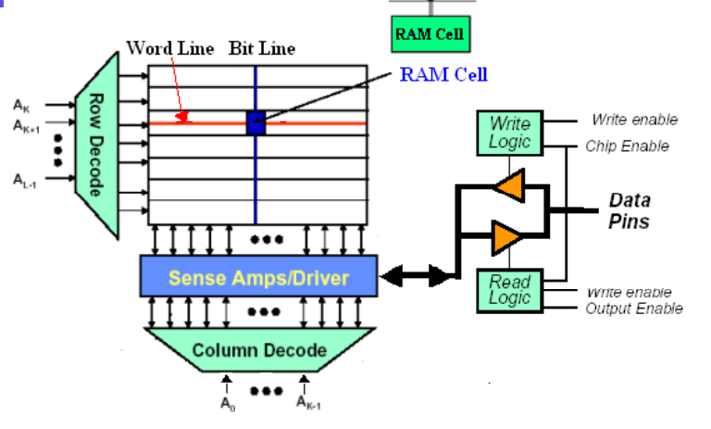
Figure 1. RAM Architecture from Lecture
The design purpose of our SRAM design was to mimic the RAM architecture in Figure 1 above in terms of writing to memory cells and reading the information from them. In our SRAM design, we will write 4-bit data, 1010 in this case, into 32 addresses locations of the SRAM. Once all the addresses have been written with data, we then start reading from the 32 address locations.
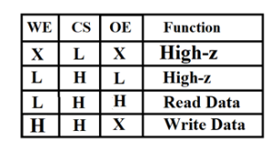
Table 1. SRAM Function Table
We based our SRAM on the function table above, specifically the read and write functions and the write enable (WE), chip select/enable (CS), and output enable (OE). From the table above, we only read data when WE is set to logic low since we do not want to write, CS is set to logic high as we need the chip enabled, and OE set to logic high since we are getting data from the memory. For writing data, we just set WE and CS to logic high to enable the chip for writing, but OE was a ‘don’t care’ because in Figure 1 Write Logic only needs write enable and chip enable.

Verilog Design:
Figure 2a. Ram Verilog Code
Figure 2b. Memory FSM Verilog Code
Figure 2c. SRAM Verilog Code

Verilog Testbench Design and Waveform:
Figure 3a. SRAM Testbench Code
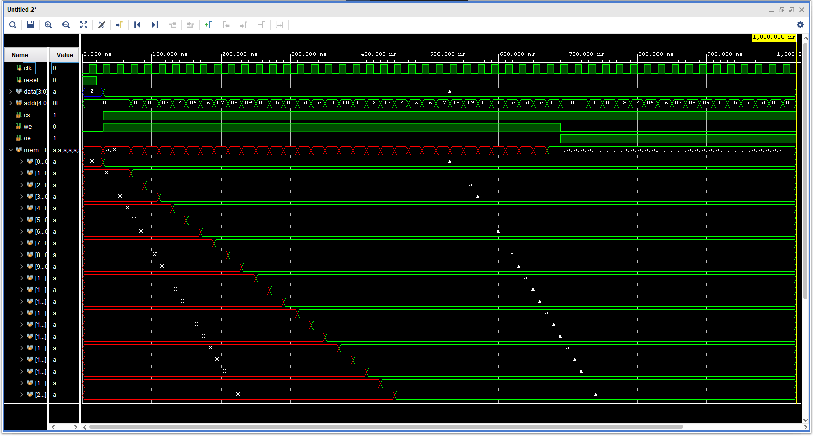
Figure 3b. SRAM Waveform

Results and Discussion:
In Figure 3b, we can see that we were writing to the different addresses in RAM with the appropriate signals active, CS and WE. We did have to include the ‘mem’ object from the ram source to see that what we wrote since we only saw red initially. Once we wrote to all 32 addresses we then began to read from those address as you can see from the switch from, WE to OE. Nonetheless, we could see that our SRAM design was performing the requirements set by the lab instructions.

Part 2: Microprocessor Datapath Design

Design Purpose:
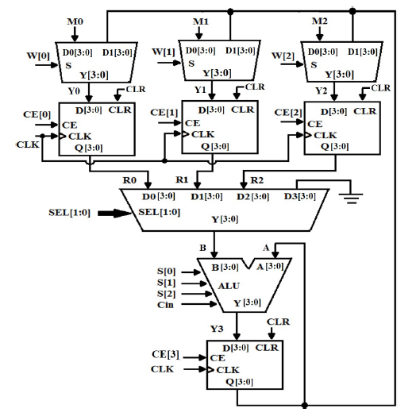
Figure 4. Simplified Microprocessor Datapath Circuit
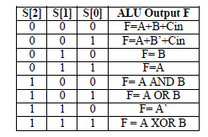
Table 2. ALU Truth Table
The design purpose of the datapath was to provide a simplified perspective of a microprocessor with familiar circuits we have constructed in the past as well as an ALU to perform various functions. We did have to incorporate structural hierarchical design in creating and wiring each of the different components into the final datapath design. In Figure 4, we had three 4-bit wide inputs we worked with as well as a 3-bit W signal that controlled the upper multiplexers in allowing data from the bottom D flip-flop or the M inputs. We also had a 4-bit chip enable signal to control the D flip-flops that allowed data to go through in the rising clock signal. SEL signal simply selected which R data to reach the ALU while the S signal selected a function for the ALU to apply based on its 3-bit pattern as shown in Table 2.

Verilog Design:
Figure 5a. 2-to-1 Multiplexer Verilog Code
Figure 5b. 4-to-1 Multiplexer Verilog Code
Figure 5c. D Flip-Flop Verilog Code
Figure 5d. ALU Verilog Code
Figure 5f. Datapath Verilog Code

Verilog Testbench Design and Waveform:
Figure 6a. ALU Testbench
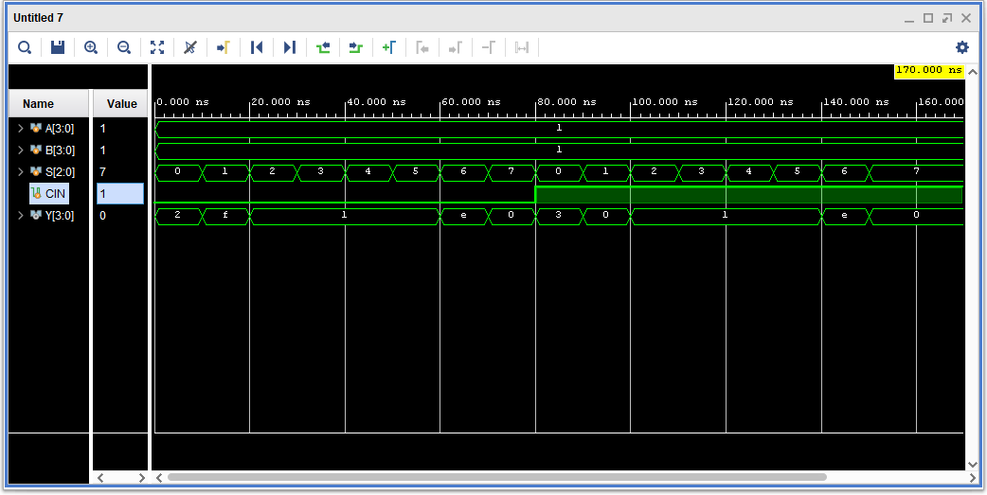
Figure 6b. ALU Waveform
Figure 7a. Datapath Testbench
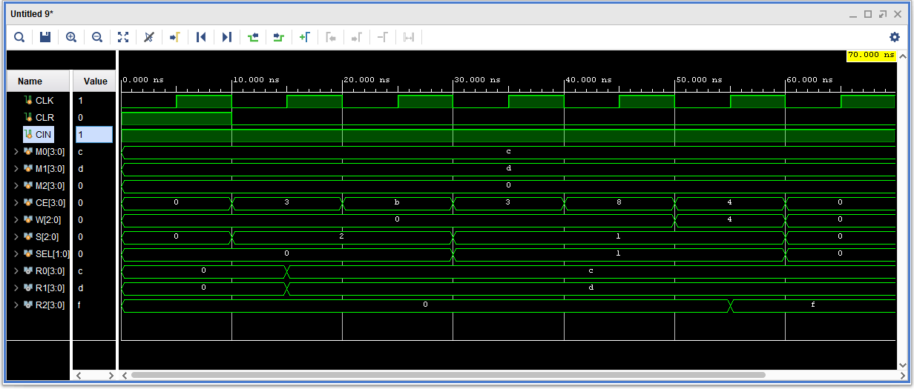
Figure 7b. Datapath Waveform

Results and Discussion:
Once we confirmed that our ALU was working based on the waveform in Figure 6b we went to test the datapath design. This of course required us to manipulate the different signals at every clock cycle as shown in Figure 7a with the various signal changes. As shown in Figure 7b above we can see the data being moved into the R values which meant that were successfully loading them and our D flip-flops were working. By the fourth clock cycle we had the ALU apply F = A + B’ + Cin to the values stored in R0 and R1 which were ‘c’ and ‘d’ in hexadecimal. With Cin being logic high we expected the result to be ‘f’.

Part 3: Microprocessor Design

Design Purpose:
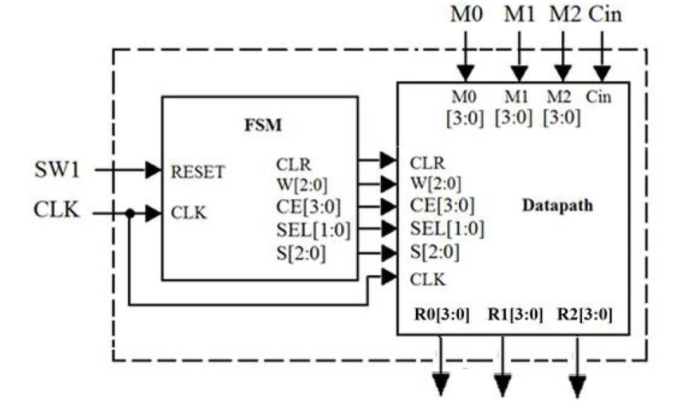
Figure 8. 4 – Bit Microprocessor Design
The design purpose of this was to finally construct the 4-bit microprocess as shown in Figure 8 above. We took the datapath we made in Part 2 earlier and connected it to a control path which was a finite state machine to create the instruction below. The microprocessor would still utilize the M1, M2, M3, and Cin ports for the data going in and the R0, R1, and R2 ports for the data going out. SW1 would control the asynchronous reset and there will be a shared CLK signal between the datapath and the controlpath.
$$R2=M1+\overline{M0}+Cin$$
In the instruction above, we noticed that it was basically pattern ‘001’ of the ALU. The secret was to set up the correct data at the appropriate ports of the ALU via FSM.

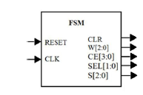
Figure 9. Controlpath Block
In Figure 9 above, we have the controlpath block which was an FSM that controlled the datapath block through the various port signals within the microprocessor.
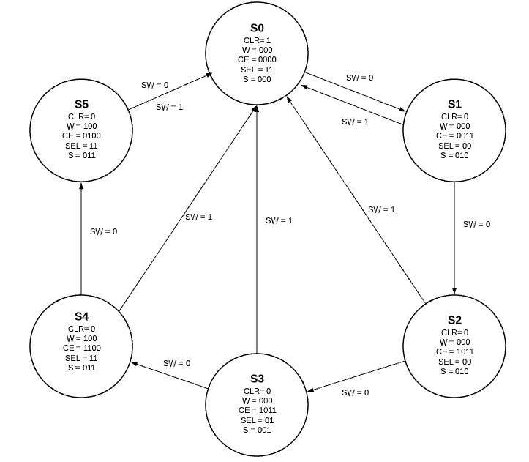
Figure 10. FSM Diagram of Controlpath
In Figure 10 above, we have the proposed finite state machine that the control path would follow in order implement the instruction mentioned earlier. It works as follows:
- At S0, reset everything and clear D flip-flops
- At S1, set clear to zero, load the D flip-flops with the input values M0 and M1 and at the rising clock have them at R0 and R1. We let R0 through to the ALU and perform F = B.
- At S2, enable the fourth D flip-flip under the ALU to process F = B which is currently R0 and process it at the next clock to have R0 at port A. Still perform F = B and still select R0.
- At S3, now select R1 which should be at port B of the ALU at this time and R0 should be at port A. Now have the ALU perform F = A + B’ + Cin. Keep the last D flip-flop enabled move the result to the appropriate multiplexer up top
- At S4, set the third multiplexer which connects to the D flip-flop of R2 to let D1 though which should be the result of the previous addition. Do not enable the D flip-flops of R0 and R1 but do enable the D flip-flops of R2 and the ALU. Have the ALU perform F = A. Also select the ground of the 4-to-1 multiplexer to avoid interfering with the result.
- At S5, at this point we only need the D flip-flop for R2 enabled in which the result from the addition would be at R2 by this time. Then we go back to S0.

Verilog Design:
Figure 11a. Controlpath Verilog Code
Figure 11b. Microprocessor Verilog Code

Verilog Testbench Design and Waveform:
Figure 12a. Controlpath Testbench
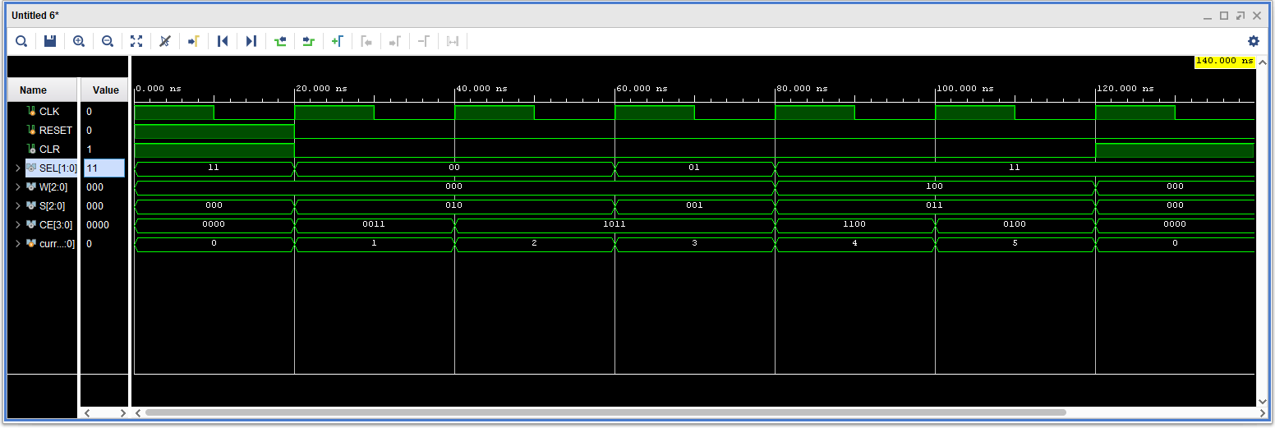
Figure 12b. Controlpath Waveform

Figure 13a. Microprocessor Testbench
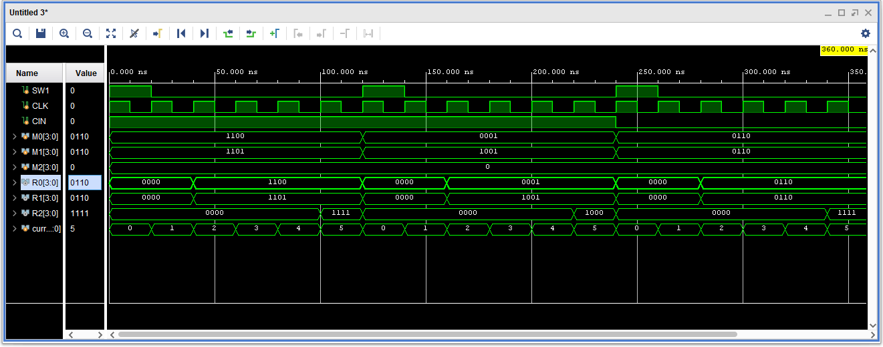
Figure 13b. Microprocessor Waveform

Results and Discussion:
Once we saw that our controlpath was going to the correct states at sending the correct signals according to its waveform in Figure 12b. We then connected it to the datapath we constructed earlier as shown in Figure 11b. In which we tested out a few inputs we see if the signals sent were truly manipulating the datapath correctly. In Figure 13b, we noticed that our microprocessor was working correctly according to our finite state machine we detailed earlier. For our first input we have M0 with 1100 and M1 with 1101. M1 will be complemented which then becomes 0010. Add M0 and $\overline{M1}$ together and we get 1110. With Cin being 1, the result will be 1111 which what we obtained in Figure 13b. Thus, our microprocessor was correctly performing the instruction, $R2=M1+\overline{M0}+Cin$.

Conclusion
This project concludes the course and the semester. We managed to incorporate all that we have learned this semester into one final design. From the behavioral circuit design of the multiplexers to the sequential circuit design of the D flip-flops as well as some structural hierarchical design methods with the microprocessor and some final finite state machine coding. We did run into some few problems during the design process, mainly finite state machine for both Part 1 and Part 3. Once we figured out how to introduce internal signals into our top-level waveform, it essentially made debugging a breeze since we did not have to include new ports up top. Nonetheless, we managed to correctly design both projects and were satisfied with the end results of our SRAM and 4-bit microprocessor.

